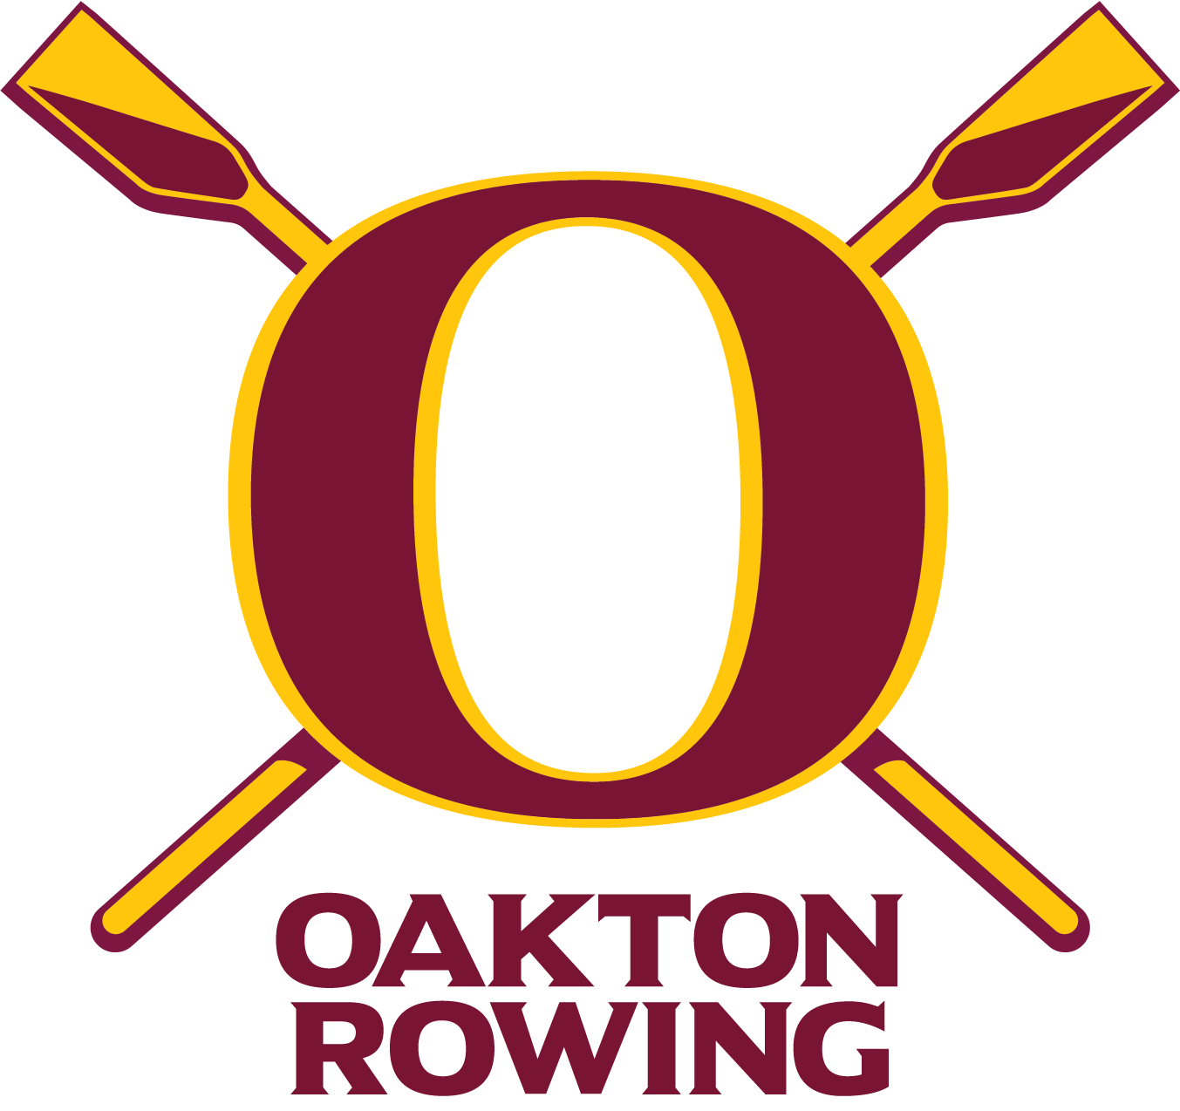Oakton Rowing
Oakton Cougar Crew Booster Club
P.O. Box 3206
Oakton, VA 22124-9206
Oaktoncrew.com
Dear ___________________,
My name is ___________ and I proudly row for my school’s crew team.
We have been in existence since 2003 and have averaged around 100 rowers per season. We are a 501(c)(3) not-for-profit organization with the purpose of supporting the sport of rowing at Oakton High School. Being a club sport, we receive no financial support from Oakton High School or the county.
Rowing teaches teamwork, communication, dedication and is life changing for most rowers. Unfortunately, it is very expensive to have a team. New boats run approximately $50,000 and even a set of oars is around $3,500. Coaches’ salaries, insurance, and bus transportation all add up quickly.
Though we ask for support from our friends and extended family members, we still can’t cover all our needs without our local community organizations also getting involved and partnering with us.
Any support would be greatly appreciated, but would you please consider making a gift of $_____?
All donations are tax deductible as we are a non-profit organization. An official receipt will be sent directly to the address requested or if you give online will be emailed automatically. Our tax ID number is 31-1827118.
To make a gift, please visit: HTTPS://donate.oaktonrowing.org/2023 or you can send a check to our address above. If you have any questions, please reach out to us at Fundraising@oaktoncrew.com.
Thank you for considering this request!
Sincerely,
_______

